IFG Challenge 1st Year Cookz Award
Three Week Programme

On completion of this three week programme the girls will have earned their Cookz badge.

Aim:
To give girls hands on experience in food preparation

Objectives:
- To teach basic food handling hygiene rules
- To work out the cost involved
- To teach how to follow a recipe
- To experience the satisfaction of producing food that can be shared and enjoyed.

Specific recipes have not been provided which allows leaders the flexibility to best work with the resources they have available. Eg seasonal produce, gifted ingredients, leaders’ own favourite recipes, cooking facilities at meeting place etc.

When delivering this subject to girls (especially in this age group) there are two issues that need to be carefully considered:
  - The cost of providing sufficient ingredients if you have a large group.
  - The situation where one or two girls “take over” the group and the quieter ones are left standing doing nothing.

Teaching Sessions/Activities:
Hygiene Rules in the Kitchen
- Always wash your hands before handling food. Use soap or liquid soap and wash hands under running water for as long as it takes you to sing “Happy Birthday”. Dry thoroughly.
- Make sure any cuts or wounds you have are covered.
- Tie long hair back.
- Take care to store food appropriately. If leaving on the bench be sure to cover away from flies.
- Keep meat in the fridge. Store cooked meat and raw meat separately. Keep raw meats at the bottom of the fridge to stop possibility of juices from the meat dripping onto other food?
- Keep all work surfaces and chopping boards really clean. A reinforced glass or plastic chopping board is more hygienic than a wooden one. Wash chopping board before using again for a different food.
- Wash your tea towels and dish cloths often. If you drop on the floor replace with a clean one.
- Any utensils that you drop on the floor need to be washed before reusing.
- Check older utensils. They may be rusty or harboring old food particles.
- Check food packaging for use by dates.

The cost of ingredients:
- What is available at no cost?
- Do you know someone who has a fruit tree with fruit surplus to their requirements?
- Or someone with a vegetable garden with excess produce?
- This could be the opportunity to teach the girls how to make peach jam or apple pies or tomato sauce or ???
- What non perishable items can be picked up “on special” at the supermarket?
If you plan your cooking sessions well in advance you can take advantage of the supermarket specials when the items you require come up.
Depending on the socio-economics of your Unit, it may be suitable to ask the girls to make a gold coin donation towards the cost of the ingredients.
You may choose to make this activity a fundraiser for your Unit. More ideas on this option later.

Involving everybody:
This very much depends on the number of girls in your Unit and the facilities for cooking available at your meeting place. Try one of the following -

Have a “Masterchef” competition:’
- Start with four girls lined up behind a long table and perform the same task – step one of a recipe eg breaking an egg into a bowl or measuring flour and sugar into a bowl.
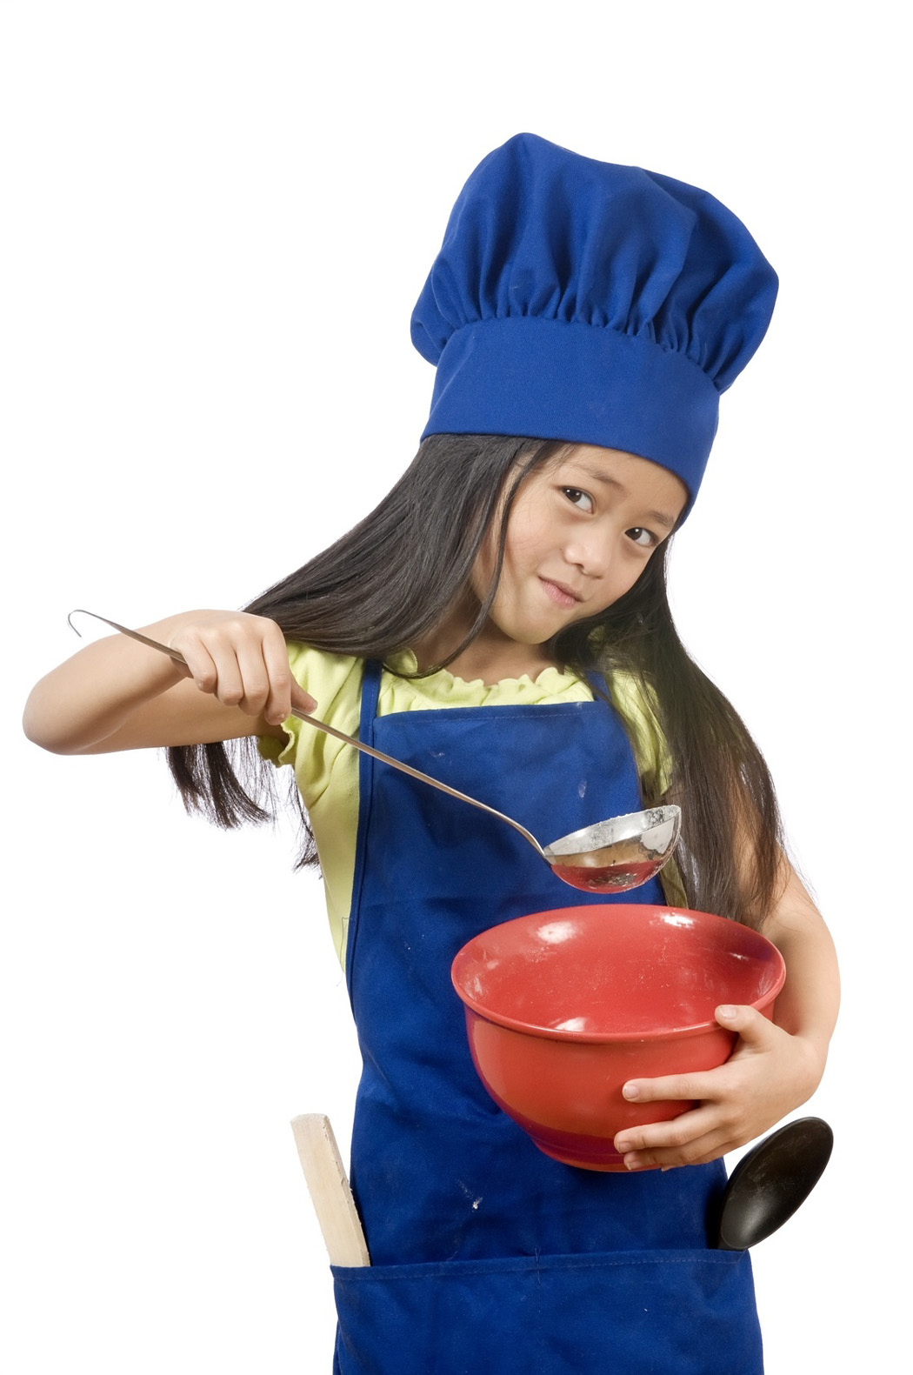
- The rest of the girls each have a marking sheet on which they choose who they think performed the task the best.
- Then another four get to do step two of the recipe and so on.
- The winners of each step go onto the next round which could be a time trial. eg first one to put the mixture into the baking tin and put into the oven.
- Could also work with salad ingredients eg grating carrots, fancy tomato cutting, mixing up salad dressing.
- Heat winners put ingredients together to make the most attractive salad.
- If you have a stage the girls would have a better view if they sat in chairs on the stage and looked down at the table.
- Leaders could lead the cheering.

Have a progressive kitchen visit.
- Girls in groups of no more than five, accompanied by a leader, go to various homes of Unit parents or church members to cook in their kitchen.
- The host cook would teach her “signature” dish (or something that she is confident in making) to a different group for each of the three weeks.
- Each group goes to a different home each week.
- Have clear communication with each host cook regarding who is responsible for paying for the ingredients. Often people like to provide the ingredients as a community service, but some people can not afford to do this.
- Remember this is an activity away from your usual meeting place so notices will be required, transport organised, and names, addresses and phone numbers of houses visited and details of drivers and their vehicles recorded. (See Health and Safety document).

Cooking to Fundraise.
Fundraising not only provides you with the money you need to go on camp or purchase equipment or uniforms, it is also very importantly a way to raise the profile of your Unit and what you are doing in the community. You may like to donate the funds to a local community project.
A tried and true fundraiser is Chocolate Truffles – easy for the girls to make and easy to sell. It is important to take orders first so you make just the right number. All girls would be involved as they could sit around tables and chat while they are making the truffles (under the watchful eyes of leaders providing quality control). A recipe for truffles is provided here but you may prefer to use your own favourite.
If you choose to do this Cookz Award in the first term and your final night is the week after this Award finishes, you may have some samples of the girls’ cooking to serve to the parents with coffee – or tempt them with a truffle so they will order more!

Activity – Costing a recipe

Gather sufficient copies for each small group (say 3 or 4 girls) of the following:
- Weekly flyers advertising the specials from the various supermarkets or food outlet stores in your area.
- A simple recipe.
- A list of the prices of ingredients not on special.
- A calculator.
- Ask each group to work out the cost of the ingredients to make up the recipe.
Share ideas about ways to save money eg if dates are on special make Date Scones instead of Raisin ones.

Truffles Recipe:
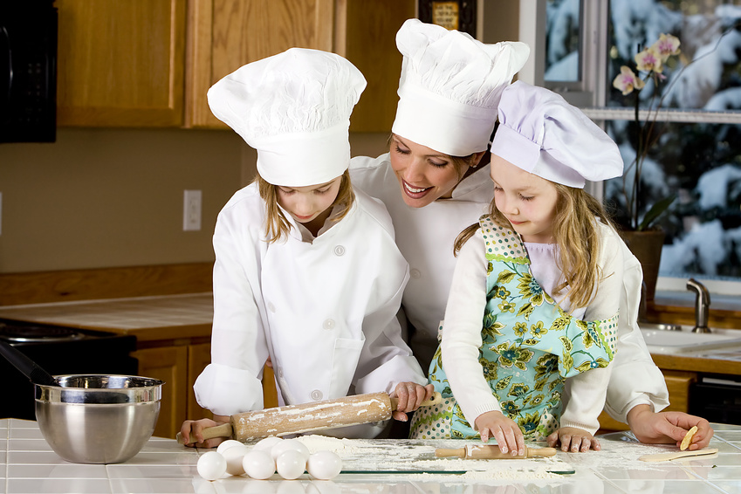
Choccy Truffles:

1 pkt Crushed biscuits )
½ cup Cocoa ) Combine
1 ½ cups Coconut )
2 ½ cups Icing sugar )

250g Butter softened )
1/3 cup Juice ) Blend & add

Roll into balls and roll into extra coconut.

Feedback from one Unit who tried this fundraiser
We doubled the recipe and made it in a roasting dish.
The double mixture makes 7dozen truffles, which we sold for $4 per dozen.
Cost to make this quantity $10-$12 (or less, but depending on packaging)
So, cost approx $1-50/doz.........profit could be $2.50-$3.50/doz

