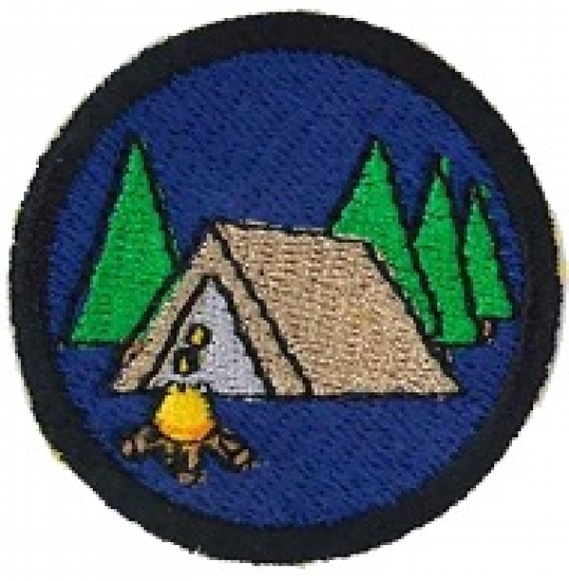
Note: In order to complete this badge, there are two nights of preparation, a third session is needed for an actual overnight camping experience which would take place at a weekend or in the school holidays.
IFG Adventure Year Three
Term Two – Weeks Five & Six Camping Adventure

Aim: To give girls the opportunity to experience outdoor camping and to learn some camping skills.

Requirement:
The requirement for this award is that each girl attends an overnight camping experience.
The girls should sleep in tents and cook on outdoor cooking equipment.

Objectives:
- To help girls learn and experience outdoor camping and cooking.
- Camping forms friendships and camaraderie between girls and this is the main reason they enjoy the experience so much.

Preparation:
Enlist the help of local outdoor camping experts or Mountain Safety as your instructors for the preliminary sessions. It is important to have someone who is experienced in outdoor camping to accompany you on this overnight adventure.

Teaching Sessions:
While the experts will know what topics to cover – here are some suggested ones:
- How to choose a good campsite.
- Clothing – type of clothing suitable for outdoor camping. What the girls will need to bring to camp e.g. changes of clothing, personal items, torch, strong shoes, warm jacket etc. There is a check list at the end of this session which you can personalise for your outdoor camp.
- Food – plan a menu for the overnight camp and then write out the list of groceries needed for this.
- Cooking - discuss how the food will be cooked i.e. on a camp fire, BBQ or gas cooker, and what utensils will be needed for this. Discuss safety precautions for fires and cookers in the outdoors.

Practical sessions:
- Packing an overnight pack for camp
- Tent pitching
- Setting and lighting a camp fire, BBQ or cooker

Resource:
Campsite:
When choosing the best spot to camp, you should look for the following:
- Relatively high, level ground
There is some truth to the saying "high and dry." Pick a spot to set up tents where it is elevated from the ground around it. In a storm, rain will flow away from your tent, rather than under it. You should never set up your tent on a slope, or you'll find yourself rolling out of your sleeping bag all night. So avoid campsites in low areas. Clear the area of rocks and branches. Place a tarp or cloth on the ground (the size to the tent) to protect the bottom. Try to pitch your tent in the daylight
- Check for a water source nearby
Water is essential for camping. You'll need it for all your drinking, cooking, and cleaning up. When choosing a campsite, check to see how far it is to the nearest water source. If there is no water handy you will need to take it all with you.
- Find an adequate area for cooking
Don't ever cook in a tent. For cook stoves, locate a flat area away from any leaves, twigs, or brush that may catch fire, and never leave an unattended campfire burning
Outdoor cooking:
If you use a public camping ground most provide a grill and picnic table. With a bag of charcoal and a spatula you're ready to make steaks, hot dogs, and hamburgers on the grill. Add a propane stove, a skillet, and a few pots, and you're ready to cook up lots of stove-top meals. Depending on your cooking skills and equipment, you can make meals that can rival home cooking. Try this recipe:
Beanie Weenie Casserole
Prep Time: 10 minutes
Cook Time: 30 minutes
Total Time: 40 minutes
Ingredients:
- 1 large can baked beans
- 1 package hotdogs
- 1 tablespoon mustard
- 1 tablespoon ketchup
- 1 tablespoon brown sugar
- 1/2 medium onion
Preparation:
Pour beans in a baking pan or iron skillet. Slice hotdogs into 1/4-inch pieces and add to beans. Dice onions and add to beans. Add mustard, ketchup, and brown sugar. Stir until everything is mixed and cook about 30 minutes. Serves: 6-8

On the overnight camp:
- Plan some outdoor games for the evening programme taking any necessary equipment. A game of spotlight normally goes down well when it is dark.
- Take a late night walk – check out the stars, listen to the silence, you could share a devotional message with the girls at this stage.
- Finish the evening round the camp fire cooking marshmallows.

Websites for other resources:
Camp fire recipes:
http://www.kids-cooking-activities.com/kids-campfire-cooking.html
http://www.netwood-cooking.html
Tent pitching:
http://www.scoutbase.org.uk/library/hqdocs/facts/pdfs/fs315085.pdf
Clothing, survival and first aid kits:
http://www.buzzle.com/articles/camping-supply-list.html

Note: This is on the CD so you can download it from there and personalise it for your girls.

Camping Checklist for the girls:  Bedding (essentials)  __ sleeping bag  __ sleeping pad  __ headrest  Clothes (tick as appropriate for climate)  __ t-shirts  __ shorts  __ jeans/pants  __ socks  __ shoes/boots  __ camp shoes  __ hat/cap  __ sweater  __ rain poncho  __ underwear  __ swim suit  __ laundry bag (plastic)  __ _____________  __ _____________  __ _____________  __ _____________  Personal Hygiene  __ tooth brush  __ tooth paste  __ face cloth  __ towel(s)  __ soap  __ comb/brush  __ other personal items  __ _____________  __ _____________  __ _____________  __ _____________  __ _____________ | Eating utensils etc:  __ plate  __ cup  __ knife, fork, spoon  __ tea towel  __ ___________  __ ___________  __ ___________  __ ___________  __ ___________  First Aid Kit  __ personal medication  __ sticking plasters  __ sunblock  __ ___________  __ ___________  __ ___________  __ ___________  __ ___________  __ ___________ | Miscellaneous Items  __ camera  __ torch  __ cards (game)  __ fishing gear  __ Frisbee  __ musical instrument  __ _____________  __ _____________

