IFG Adventure – 2nd Year
Term One, Weeks One Two and Three Aquaticz Physical
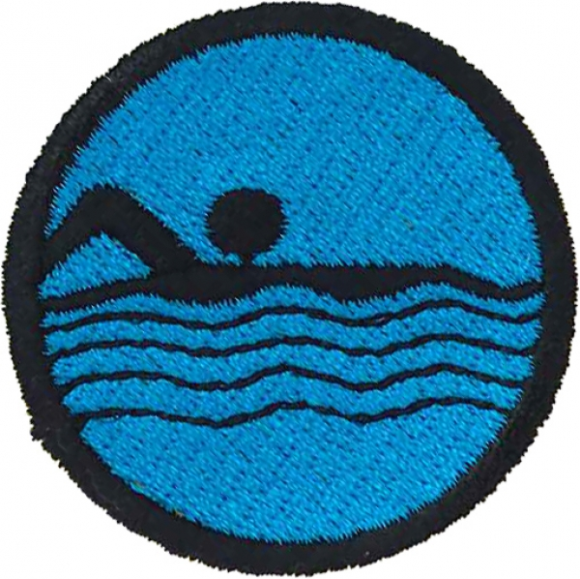
Programme Overview

This badge is one of the physical components of the Programme.
It can be done in several ways depending on what facilities you have available. You may have a leader, parent, or church member with a home pool you can use. If not investigate using a local public or school pool.
You will need to look at the abilities of your group of girls. Some may already be very proficient at swimming while others will have no confidence at all. Three weeks is not very long and you will not have enough time to teach a non swimmer to swim 10 metres. You will therefore need to be flexible with your goals.

For the three weeks of this badge the meeting venue will be the pool. Notices advising the girls and their families will need to be sent out in plenty of time. Remember to include all gear you require the girls to bring with them including warm clothing for afterwards.

Aim:
The Aim of this Award is:
- To have fun.
- To get the girls physically active,
- To work together as a team.
- To improve their water confidence
- To challenge girls to work towards improving their swimming skills.

Equipment Needed
- Administration stuff – roll book, whistle, etc
- Completed risk management sheet
- First Aid Kit
- Devotions
- Any equipment required for the activities you have chosen for the night
- If you think the evening might be cold it might be a nice idea to provide a hot drink for the girls after their swim.

Suggested programme outline for each night
- When the girls arrive call the roll and take care of any administration prior to them getting in the pool.
- Give them clear instructions regarding the rules of the pool. You may need to repeat these each week. Try to get this done as quickly as possible so they can have as long as possible in the pool.
- You can talk to the girls about how they might assist someone who is not confident in the water.
- If the pool you are using is outdoors you need to consider whether there is somewhere under cover for the girls before and after they have swum in case the weather is wet or cold.
- Send them to get changed OR get the girls’ to put their togs on at home and wear a top and shorts over them, till swimming time.
- Allow for plenty of swimming time
- Get dressed (and have a hot drink)
- Sit the girls down in a dry warm place and review the lesson objectives.
- Remind them to always participate with a good attitude.
- Close in prayer then hand out any notices to each child as they leave. If you hand out notices before the prayer they will not listen.
- Home time. Make sure the girls stay with you as a group until their parent/caregiver comes to collect them.

Swimming pool rules (you may want to add to this list)
- No running in the pool area
- Go to the toilet before getting in the pool
- No pushing or rough play in the pool
- No diving or jumping into the pool unless instructed to do so by a leader

Week One - because the first week of this subject is the first meeting night for the year you may like to make it a family night and encourage the girls to invite friends who may want to join IGF. If you choose to does this ask each family to bring a picnic tea with them. The programme for this first week would then be a little different as you may have other children including brothers who are also swimming. Everyone can swim either before or after tea depending on what time your Unit meets.
It may be a good idea to let the girls have a free swimming night. Be assured they will easily fill the time. Use this opportunity to watch the girls and assess their swimming abilities. This will assist you in choosing appropriate activities for the following two weeks.

Programme suggestions for the next two weeks depending on the abilities of your leaders and girls:
- Play various games designed to increase confidence in the water. (This may be all some girls are able to do). Some game suggestions are listed below.
- Swim 10 metres of any stroke without a time limit.
- Use lesson plans found online that will provide many ideas of activities you can use. Swimming New Zealand has a series of lesson plans designed for different ability levels. Go to http://www.swimmingnz.org.nz/education/school-teachers-tool-box/lesson-plans
- Either; Participate in a water safety session at a pool with a swim instructor.
This can be organised through your local swimming club or swim school. Inquire through the swimming club committee and ask if they could teach the whole group at one time. For this session, the girls may need to take clothes to swim in, and a life jacket. Check with your instructor.
- Or; The leader can instruct in the water safety session using the following or by using the Lotto Swim Safe teachers Manual:
- Swim/float or tread water for 1 minute without flotation support.
- Learn how to remove clothing correctly without touching feet or other parts of the body on the pool bottom.
- Learn how and when it might be safe to take shelter under the hull of an up-turned boat.
- Swim 10 meters fully clothed. (It is very difficult) this will illustrate to them that it is foolish to swim in clothes.

- Learn the HELP survival position:
Heat Escape Lessening Position
This practice covers the recommended water rescue procedure for performing the heat escape lessening posture (HELP) position. You need a floating device to perform this technique.
If you are wearing a lifejacket or PFD (Personal Flotation Device) or buoyant clothing, your survival time can be increased by adopting the HELP position. This position somewhat protects the core areas of the body from rapid heat loss.
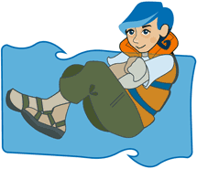
- Keep your legs together
- Press both arms against your upper body
- Keep your head out of the water
You sometimes may be immersed in cold water for prolonged periods of time or shore is too far away, rescue is not imminent, no boat is available to get into or on top of, and no flotsam is available. You need to assume a defensive posture (as in picture above) to conserve heat and increase survival time.
- Learn what to do if another person falls into deep water without getting in yourself:
Do not get in yourself
Send another person to call for an adult
Pass the victim a rope, bottle, bucket or other floating objects
Pass a rigid object like a pole, oar or branch
Brainstorm other ideas of what could be given to the victim

- Learn the purpose of, and how to stay in a huddle and its benefits.
The HUDDLE position is useful for small groups wearing lifejackets. It works on the same principle as the HELP position by reducing the loss of body heat.
Get your group to put on clothes and life vests. If you don't have life vests, use a buoyant aid like a rescue ring or such. Let them float in a "huddle" position to practice staying afloat as a group in case of an emergency.
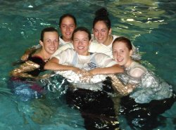
The younger children get in the middle of the group while everyone else gets as close as possible, holding on to one another by wrapping their legs together and putting their arms around their "buddies." This activity will stress the importance of staying in a group, which helps everyone stay warm and enables rescuers to see people in a large body of water.
- Hold on to buoyancy aids
- Press the sides of your bodies together
- Put your arms around each other's backs at waist or shoulder level

Water Games

“Catch 5 Keep away”
3 teams use a tennis ball to play keep away.
The object for each team is to keep the ball away from the other team and to attempt to complete 5 “catches” in a row.
When they are successful they score 1 point.
Play in chest deep water
Use coloured polo/swimming caps to differentiate teams

“Steal the Bacon”
2 teams are aligned facing each other on opposite sides of the pool. Objects are thrown in the middle and teams race to retrieve.

“Shark and Minnow”
One swimmer is in the center of the pool and is labeled the “shark”. The other swimmers are on one side of the pool and are labeled “minnows”.
The object is for the minnows swim to the other side of the pool without being touched by the shark. If minnows are touched they then become sharks. This continues until only 1 minnow is left and therefore declared the winner!

“Sink”
From a front float position; exhale until you sink to the bottom. Try to save enough air to stay on the bottom for 3 seconds.

“3 Float combo”
Float on your back until the instructor blows the whistle. Roll over into survival
float position. Hold survival float until the whistle blows.
Then pull into Jellyfish float and hold until you are out of air and stand up.
The challenge is to complete all three without touching the bottom.

“Walrus”
From the “treading water position” bring both feet out of the water in front of your face and clap the bottom of your feet together like a walrus claps.

“Squirt Gun”
Put your hands together with your fingers interlocked as if in a “praying position.
Submerge them and allow water to seep in. Now remove from water and flex your knuckles together and squirt water like a squirt gun.

